**Comprehensive Examination**

**(EC-3 Regular)**

Course No. : SE ZG544

Course Title : Agile Software Processes

Nature of Exam : Open Book

Weightage : 40%

No. of Pages = 3

# No. of Questions = 7

Duration : 2 ½ Hours

Date of Exam : 18/05/2024 (AN)

Note to Students:

1. Please follow all the *Instructions to Candidates* given on the cover page of the answer book.
2. All parts of a question should be answered consecutively. Each answer should start from a fresh page.
3. Assumptions made if any, should be stated clearly at the beginning of your answer.
4. A two-week iteration is being worked on by an Agile team. As a team member, you have been told to concentrate on "first things first." Arrange the following activities into the four quadrants listed below. Which quadrant should you concentrate on? [6]

|  |  |
| --- | --- |
| 1. Urgent and Important | 1. Not Urgent but Important |
| 1. Urgent but Not Important | 1. Not Urgent and Not Important |

|  |  |
| --- | --- |
| 1. Design 2. Fixing bugs that prevent progress. 3. Iteration planning 4. Learning new technologies 5. Working on management assignments that arrive late and have tight deadlines. 6. Refactoring 7. Tracking|follow-up and control | 1. Preparing a presentation after it has been postponed till the last minute. 2. Personal arrangements/errands 3. Production problems 4. Helping other team members with urgent tasks 5. Mingling 6. Testing |

**Answer -**

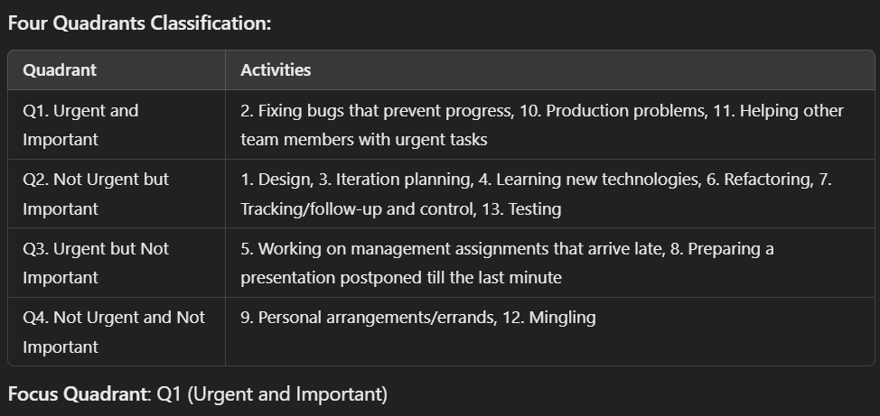

1. Choose three agile techniques that have an impact on process quality and three others that have an impact on product quality. Describe briefly how each of these has an impact on process and product quality. [6]

**Answer:**

**Agile Techniques Impacting Process Quality:**

1. **Daily Stand-ups**: Improves communication and transparency, ensuring blockers are quickly addressed.
2. **Retrospectives**: Encourages continuous improvement by identifying process inefficiencies.
3. **Time-boxing**: Promotes focus and prevents scope creep by adhering to fixed time intervals.

**Agile Techniques Impacting Product Quality:**

1. **Test-Driven Development (TDD)**: Ensures code quality and minimizes defects by focusing on testing during development.
2. **Continuous Integration (CI)**: Enhances product stability by frequently merging and testing code.
3. **Pair Programming**: Improves code quality and reduces bugs through collaborative coding.
4. When doing a retrospective in an agile software development environment, agile retrospective methods and principles should be used and promoted. Explain how the Agile practices: Whole team, time box, measures, abstraction, diversity and Agile games may be used in a retrospective. [6]

**Answer:**

**Agile Practices in Retrospectives:**

1. **Whole Team**: Ensures diverse viewpoints and collective decision-making for improvements.
2. **Time Box**: Keeps the retrospective focused and efficient, ensuring timely completion.
3. **Measures**: Tracks improvement areas with metrics to evaluate progress in subsequent iterations.
4. **Abstraction**: Helps participants step back to identify broader patterns or root causes.
5. **Diversity**: Encourages contributions from all team members, leveraging varied perspectives.
6. **Agile Games**: Makes retrospectives engaging and fosters creativity while addressing serious issues.
7. [2+4]
8. The following are some of Scrum's characteristics: Discipline, three major roles and quality. How do you back these claims?

**Answer:**

* **Discipline**: Scrum ceremonies (Daily Stand-ups, Sprint Planning, Reviews) promote structured and disciplined workflows.
* **Three Major Roles**: Product Owner, Scrum Master, and Development Team define clear responsibilities and collaboration.
* **Quality**: Continuous feedback loops through sprint reviews and testing ensure quality deliverables.

1. Scrum has several strengths: Prioritized delivery, non-prescriptive practices performed during a sprint, Demonstrated success across the software industry, Status transparency, Team accountability, Continuous delivery. How do you back these claims?

**Answer:**

* **Prioritized Delivery**: Product backlog refinement ensures the most valuable features are developed first.
* **Non-prescriptive Practices**: Flexibility allows teams to adapt Scrum to their needs.
* **Proven Success**: Widely adopted and successfully applied across industries.
* **Transparency**: Sprint boards, daily stand-ups, and reviews keep progress visible to all stakeholders.
* **Accountability**: Clear role definitions and collective ownership ensure responsibility.
* **Continuous Delivery**: Frequent, incremental releases minimize risks and enable rapid feedback.

1. The product backlog has been prioritized and estimated at 200 points. The team's sprint velocity has been determined to be 15 to 20 points per sprint. The team runs sprints every two weeks. The first sprint will conclude on June 21,2024. The deadline for the release has been set after 10 sprints.

Suppose, though, that in the first sprint, the team accomplished 11 story points rather than the 15 to 20 it had estimated. The team updated the release plan to reflect this actual velocity, then the team ran five more sprints, each time updating the release plan. By the end of sprint 6, the team had an observed velocity range of 8 to 14 points, with an average of 11. [3+3]

1. How many story points do you think you'll be able to finish by the deadline using low and high velocity?
2. After Sprint 1, B.After Sprint 6.

**Answer:**

* **After Sprint 1 (Velocity: 11)**:
  + **Low Estimate**: 11×10=11011 \times 10 = 11011×10=110 story points.
  + **High Estimate**: 11×10=11011 \times 10 = 11011×10=110 story points.
* **After Sprint 6 (Velocity Range: 8–14, Average 11):**
  + **Low Estimate**: 8×10=808 \times 10 = 808×10=80 story points.
  + **High Estimate**: 14×10=14014 \times 10 = 14014×10=140 story points.

1. The agile methodology is used to deliver most projects in the IT industry and elsewhere. Fill in the Agile values from Agile Manifesto in the table below. Relevance/Benefits to the IT and non-IT worlds, as well as the tools/practices used by the Agile team (local or remote) to put these values into action. [6]

|  |  |  |
| --- | --- | --- |
| Agile Values | Relevance | Tools/Agile Practices |
|  |  |  |

**Answer**

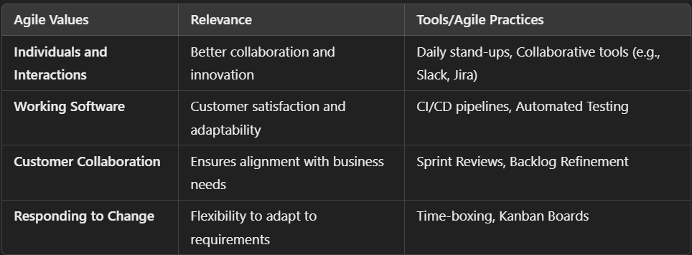

1. Develop an estimate for the schedule required to develop course materials for the following two modules.

Module-1(Epic): (Introduction, Course Objectives, and Agile Overview)

Module-2 (Epic): (Agile Fundamentals)

Work is divided into two-week sprints, and we have a velocity of completing 20 story points of work in each two-week sprint. The following breakdown of Module-1 and Module-2 stories are identified and estimated in story points. [4]

|  |  |  |  |
| --- | --- | --- | --- |
| Title | Estimate |  | Estimate |
| **MODULE-1: Introduction, Course Objectives, and Agile Overview** | **8** | **MODULE-2: Agile Fundamentals** | **17** |
| Introduction and Course Objectives  Introduction | 2 | Agile History, Values, and Principles | 11 |
| Course Objectives | 1 | Agile Manifesto Values | 3 |
| Introduction | 1 | Agile Manifesto Principles | 8 |
| Agile Overview | 6 | Agile Benefits and Obstacles to Becoming Agile | 6 |
| What Is Agile? | 3 | Agile Benefits | 3 |
| Agile Perception versus Reality | 3 | Obstacles to Becoming Agile | 3 |

1. Determine the Initial Schedule (Epic level) and updated schedule (after breakdown) required to prepare the course contents.

**Answer**



